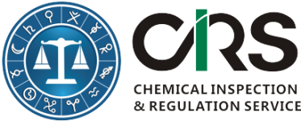
CHEMICAL INSPECTION & REGULATION SERVICE LTD.
SINGLETON HOUSE, LAURENCE STREET
DROGHEDA, CO. LOUTH, IRELAND
TEL: + 353 41 9806916 | FAX: +353 41 9806999
WEBSITE: http://www.cirs-reach.com

Workshop Registration Form

Attendee Information
First Name (*):
Last Name (*):
Email (*):
Company or Organization (*):
No. of Attendees and Their Names :
Maximum 2 attendees per company:
Telephone :
Pre-submitted Questions About Registration of Imported Hazardous Chemicals and China GHS
* Mandatory Fields
- Please send this form to lila.tao@cirs-reach.com after it is completed; or contact +86 571-87206521 for assistance.

