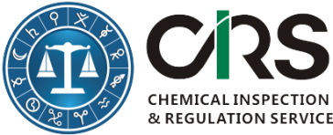
Order Form for the English Version of 2015 Catalog of Hazardous Chemicals

First Name(*):
Last Name(*):
Email (*):
Company or Organization(*):
Company Address(*):
Company VAT No. | Required for EU companies
Affiliated companies:
Which option would you like to choose? | Option 1: 1,000 RMB or 160 USD or 150 EUR (Depending on the exchange rate)  English Version of the Catalog of Hazardous Chemicals in China(2015) in excel format;  Option 2: 1,500 RMB or 240 USD or 225 EUR  English Version of the New Catalog of Hazardous Chemicals in China (2015); One to one comparison between the Catalogs (2002) and Catalog (2015).
Comments | (E.g. We would like to pay in Euros or USD)
Which regulations are you interested? (Consultants will be assigned according to your choice. You can also choose consultants you know.) | Industrial Chemical Regulations (New Substance Notification, Hazardous Chemicals Management, Restricted Chemicals) in China;  Global GHS (SDS/Labeling/Packaging);  Cosmetic Regulations in China;  Pesticide Regulations in China;  Biocides Regulations in China;  Food Additive/Food Packaging/Food Contact Material Regulations in China;
Please complete this form and send it to ethan.zheng@cirs-group.com. We will send an invoice to you immediately after receiving this completed order form and send you above documents afterward.  More China chemical regulation information can be found here. |  | CIRS Bank Information  Beneficiary Name: CIRS Ltd  Bank Name: Bank of Ireland  Bank Address: Wilton, Cork, Republic of Ireland  Sort Code: 902805  Account #: 90404884  BIC/Swift: BOFIIE2D  IBAN: IE15 BOFI 9028 0590 4048 84
Signature: Print Name: Date:

