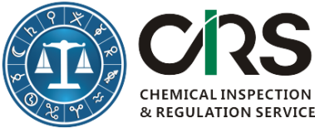
CHEMICAL INSPECTION & REGULATION SERVICE LTD.
11/F., Building 1, Dongguan Hi-Tech Park, 288 QiuYi Road,
Binjiang District, Hangzhou 310052, China
TEL: + 86 87206598 | FAX: +86 87206533
WEBSITE: http://www.cirs-reach.com/

Application Form
Applicant Information
First Name(*):
Last Name(*):
Email (*):
Company or Organization(*):
Telephone:
Questions or comments:
Services Information
Items |  | Please √ what you need
- Detailed comparison (in English) between Hygienic Standard for Cosmetics (2007) and Technical Safety Standard of Cosmetics (2015, Final) [Original price: 470 USD/3,000RMB, Current price: 380USD/2,500RMB ]

- List of banned and restricted ingredients, of allowed sunblock agents, preservatives, colorants and hair dyes in the Technical Safety Standard of Cosmetics (2015,Final) in English [Original price: 315US/2,000RMB, Current price: 228USD/1,500RMB ]

Please finish this form and send it to service@cirs-reach.com

